- What is Data Science and Machine Learning: Extract patterns from an unknown source/set of data, especially Non-Obvious Pattern in Dataset.

- Titanic Dataset: https://gist.github.com/fyyying/4aa5b471860321d7b47fd881898162b7
- Side-Task: Predict whether a person will survive or not in the Titanic.

- Obvious Pattern in Dataset: Females and children were survived because they are rescue first generally.

- Non-Obvious Pattern in Dataset: Men in 3rd seat usually survived (hidden pattern).

- DIKW (Data, Information, Knowledge, Wisdom) Pyramid:

- Data Science is a collection of Database Systems, AI/Machine Learning Coding, and Math and Statistics.
- It involves: Data Collection, Data Visualization, Analytics on data, Representation the patterns.

DIKW Pyramid:
- Standard model of structural relationship between wisdom knowledge, information, and data.
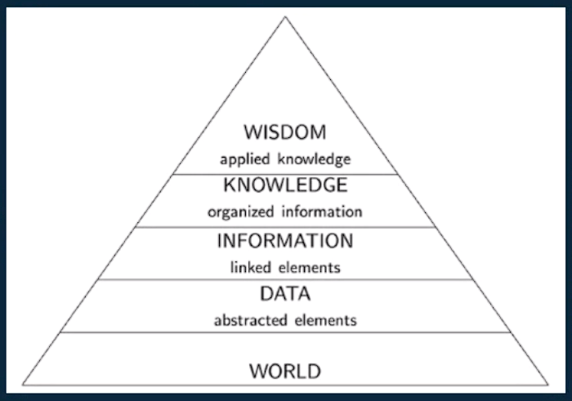
- Let’s assume we got a data-sheet of students scored in exams. What would be the average score?
- Data: Various students got various marks forms a dataset.
- Information: Finding how much marks on average is in various students like two professor’s lectures.
- Knowledge: One of the professor’s class scores more or less, the difference between them, etc.
- Wisdom: Felicitate (award) toppers (top-3) students from this analysis who actually did well.

- Data Analysis: Data filtering and transforming it in a way it can fit in a model.
- Data Visualization: Representation of data graphically for visualization.
- Data Mining: Finding patterns in the data by performing some operations.

Data Science Pyramid:
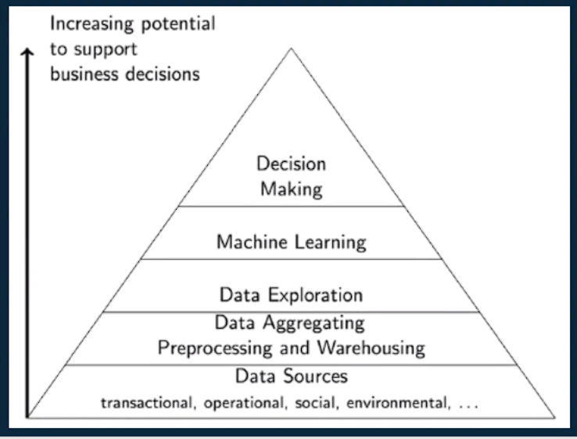

Applications of Data Science:
- Information Retrieval
- Text analysis
- Natural language processing
- Pattern Recognition

